1. Agenda:
   1. How to enable Kafka Producer Idempotence in Spring Bean.
2. 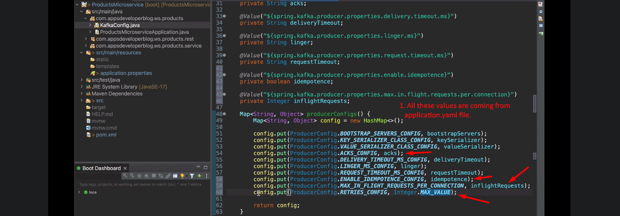
3. 